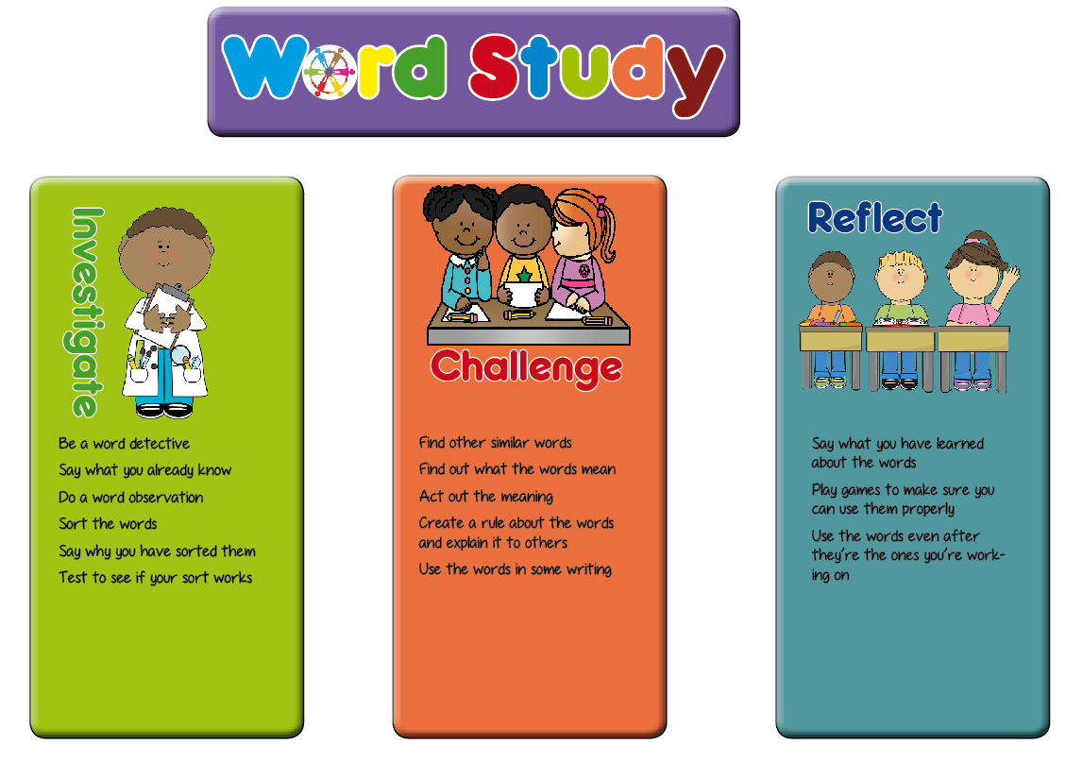
Planning Ideas

Hopefully these ideas will be a springboard for the activities you plan in your classroom. These are generic activities which fit in with the word study teaching sequence. Use them alongside the planning ideas for your specific unit of work from www.wordstudyspelling.com, to create your own planning for the unit. A blank planning template is also on the website which you could use or adapt.

Investigate | Challenge | Reflect and Retreieve
- Say what they know about the words (modelling)  - Sort into words the children know/don’t know  - Do a closed sort (give the children the criteria to sort against)  - Do an open sort (don’t give sorting criteria)  - Sort and say why they have sorted the words in the way they have  - Play spot the difference with two or three words with the similar patterns eg terrible, repeatable. What’s the same and different about them?  - Explain what they think the spelling rule sort is  - Do a sound sort (no printed words – say the words and the children have to sort them into agreed criteria) (this is a bit like a dictation sort once you’ve explored the words a bit)  - Share ideas for why words are sorted in a particular way and use to directly teach what the pattern they need to remember is.  - Speed sort once the spelling pattern is established – how quickly can they demonstrate learning?  - Sort into different word classes (where appropriate) | - Do a word observation on one of the words.  - Explain to someone else how to do the word sort  - Create a poster or set of rules to explain to someone else how to sort the words.  - Create sort headings for someone else to use to do a closed sort  - What’s the morphology of the word? Use this to identify other words that follow the same spelling pattern. (www.membean.com)  - Explain how to use the words  - Act out the meaning of the words  - Can you put the words in a sentence?  - Can you create a silly sentence or paragraph with as many of the words in it as possible?  - Can you find other words with the same pattern to add to your word sort?  - Can you write a crossword puzzle where the clues are the meanings of the words?  - Homophones and homonyms – make a joke containing the pairs or triads of words (or find one online and explain to someone why it’s funny)  - Right/wrong game – children create some statements about the ways the words are spelled and challenge each other to work out which statements are true or false. (you could also do this with sort criteria for closed sorts).  - Choose words and do a zone of relevance comprehension activity or a synonym tree to demonstrate words with similar meanings (how many share etymological links?). See word study Pinterest board for ideas  - Divide words from the list into different word classes (where appropriate)  - Create part-part-whole type spellings where the two parts are the root word and the prefix/suffix and the whole is the completed word (especially good for words where changes need to be made to the root word before adding the suffix)  horror ible  horrible  happy ness  happiness | - A quick spelling quiz!  - Do a collaborative test (see assessment on www.wordstudyspelling.com) this encourages articulation of the spelling patterns that have been taught.  - Play hangman with the words  - Play bingo with words  - Build with magnetic letters (could be timed)  - In pairs, take turns to spell the words  - Spelling investigation writing – use different colours  - Have a poster area for children to add words to the word sort as they find them in their reading  - Play Pointless with words from the list  - Create a game using the words and share with others in the group  - Give a piece of text with some of the target words spelled incorrectly and the children have to find and correct them.  - Speed sort or sound sort – refer back to initial activities for this teaching unit – how quickly and accurately can their learning be demonstrated?  - Write a crazy sentence or paragraph containing as many of the words as possible.  n.b. retrieval practice activities should be one that encourage independent recall of the words and their spellings

